PARTS OF THE BODY
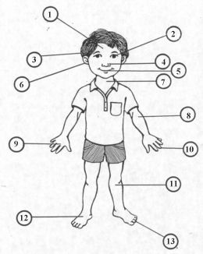
head
eye
nose
mouth
hair
ear
neck
arm
finger
hand
foot
leg
toe

